**Internet of Surveillance equipment**

**Using Packet Tracer**

B.Tech. Lab Project Report on

19ECTS4005-Technical Proficiency training

Name: V Lavanya

ID : 190040550



DEPARTMENT OF ELECTRONICS & COMMUNICATION ENGINEERING

KONERU LAKSHMIAH EDUCATION FOUNDATION

VADDESWARAM, GUNTUR

June, 2021

**CERTIFICATE**



I hereby certify that the work which is being presented in the B.Tech. Project

Report entitled “**Internet of Surveillance equipment Using Packet Tracer**”,

submitted by **V Lavanya** bearing with **ID No.190040550** in partial fulfilment of

the requirements for the award of the Bachelor of Technology in Electronics &

Communication Engineering and submitted to the Department of Electronics &

Communication Engineering of KLEF, Vaddeswaram, Guntur is an authentic

record of my own work carried out during a period from June 2021 to

November 2021.

Signature of Candidate

V Lavanya

**ACKNOWLEDGEMENT**

It is great pleasure for me to express my gratitude to our honourable

President Sri. Koneru Satyanarayana, for giving the opportunity and platform

with facilities in accomplishing the project-based laboratory report.

I express the sincere gratitude to our principal **Preetham Reddy** for his administration towards our academic growth.

I express sincere gratitude to our Coordinator **Dr. Revathi** for his

leadership and constant motivation provided in successful completion of our

academic semester.

I record it as my privilege to deeply thank our pioneer **Dr. M. Suman**

**HOD** for providing us the efficient faculty and facilities to make our ideas into

reality.

I express my sincere thanks to our project supervisor for his novel

association of ideas, encouragement, appreciation and intellectual zeal which

motivated us to venture this project successfully.

Finally, it is pleased to acknowledge the indebtedness to all those who

devoted themselves directly or indirectly to make this project report success.

**Sincerely,**

**V Lavanya**

**190040550**

**Abstract**

In the current scenario, it is necessary to ensure safety and security due to

influence of modern technology. Especially places like Airport, schools,

colleges, Home etc where security is high priority, needs an intelligent system

which detect intrusion and objectionable objects with less human intervention.

Hence, camera helps to capture passenger from remote view and sensors can be

used to sense objectionable objects. Though body scanners and detectors are

available but passenger has to undergo multiple steps of security checks which

is time consuming.

Hence, there is a need for an integrated device which can perform various

security check at the same time and ensures to wired or wireless network

enables faster data transmission through wired or wireless network. This kind of

systems can also help security agent to monitor and control the security

remotely resulting in human error free system. Also, when such system is

integrated with smart phone can result in fast notification and alert system.

**TABLE OF CONTENTS**

1.Introduction

1.1 Objective

1.2 Block Diagram

2. Methodology

2.1 Working

3. Simulation

3.1 Topology

4. Outputs

5.Result

5.1 Advantages

6. Conclusion

6.1 References

6.2 Future Scope

**INTRODUCTION**

An IoT network refers to a collection of interconnected devices

that communicate with other devices without the need for human involvement,

such as autonomous cars, smart appliances, and wearable tech.

An IoT ecosystem consists of web-enabled smart devices that use

embedded systems, such as processors, sensors and communication hardware,

to collect, send and act on data they acquire from their environments.

IoT Devices share the sensor data they collect by connecting to an IoT Gateway

or other edge device where data is either sent to the cloud to be analyzed or

analyzed locally. Sometimes, these devices communicate with other related

devices and act on the information they get from one another. The devices do

most of the work without human intervention, although people can interact with

the devices -- for instance, to set them up, give them instructions or access the

data.

**Block Diagram:**

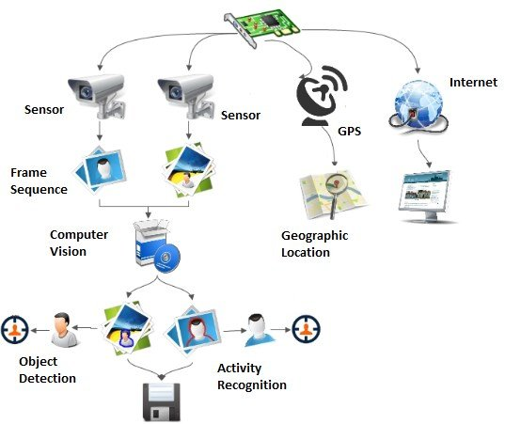

**Methodology**

This method integrates different types of sensors like camera,

carbon-di-oxide detector, carbon monoxide detector, metal detector via IOT

registration server /home gateway to smart phone and alert systems. The

proposed method used CISCO Packet tracer (PT) to simulate Internet of

surveillance system for better understanding and analysis of new integrated

environment. The simulated environment includes a backbone network was

used as network interface to connect required smart things and sensors. Smart

things are the physical objects that was connected to registration server or Home

gateway through network interface which can be wired or wireless. This work

concentrated on both wired and wireless simulated environment for

performance analysis.

The following are the components of CISCO packet tracer used in Wired

simulation Environment For Backbone Network.

**1.DLC100 Home gateway:**

This is IoT registration server configured with Internet of

Everything (IoE) services. The smart things can directly register to it for

accessing IoE services. This gateway provides both ethernet ports (wired) and

wireless access point with secured WEP / WPAPSK / WPA2 enterprise. This

gateway is connected to the Internet through Internet WAN ethernet port. This

gateway host web interface through which all smart things connected to it can

be remotely managed. This device is configured with ip address 192.168.25.1

and SSID=HomeGateway which will be used as IoT gateway address in smart

things.

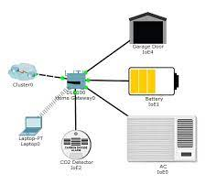

2**. Smart Phone:**

This is to simulate smart device at user end to receive notifications

and also program logic to control and manage different smart things is placed in

this device. This device is ip configured and connected to home gateway using

SSID.

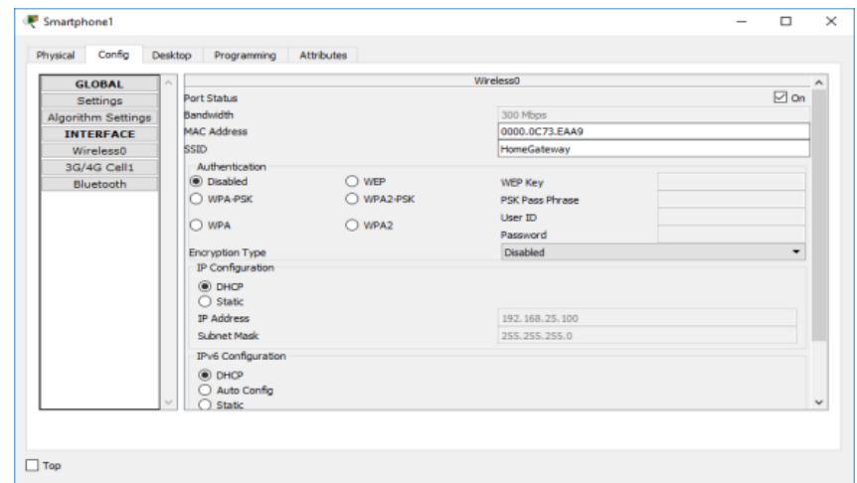

**3.Motion Detector:**

Detects motion from mouse movement.

**Features:**

Registration Server Compatible Automatically deactivates after 5 seconds

without any mouse movement.

**Data Specifications:**

Message Format: [state]

state: HIGH=activated,

LOW=inactive

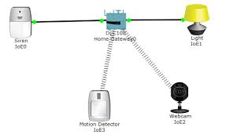

**4. Webcam :**

A camera device that records and sends data

**Features:**

Registration Server Compatible Off, On, Video recording

**Data Specifications:**

Message Format: [state]

state: 0 = off, 1 = on

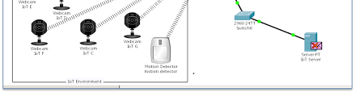

**5. Old Car:**

A car having lots of problems. In this work it is used as a source of

poisonous gases closely simulating source of explosives.

**Simulation**

**Topology:**

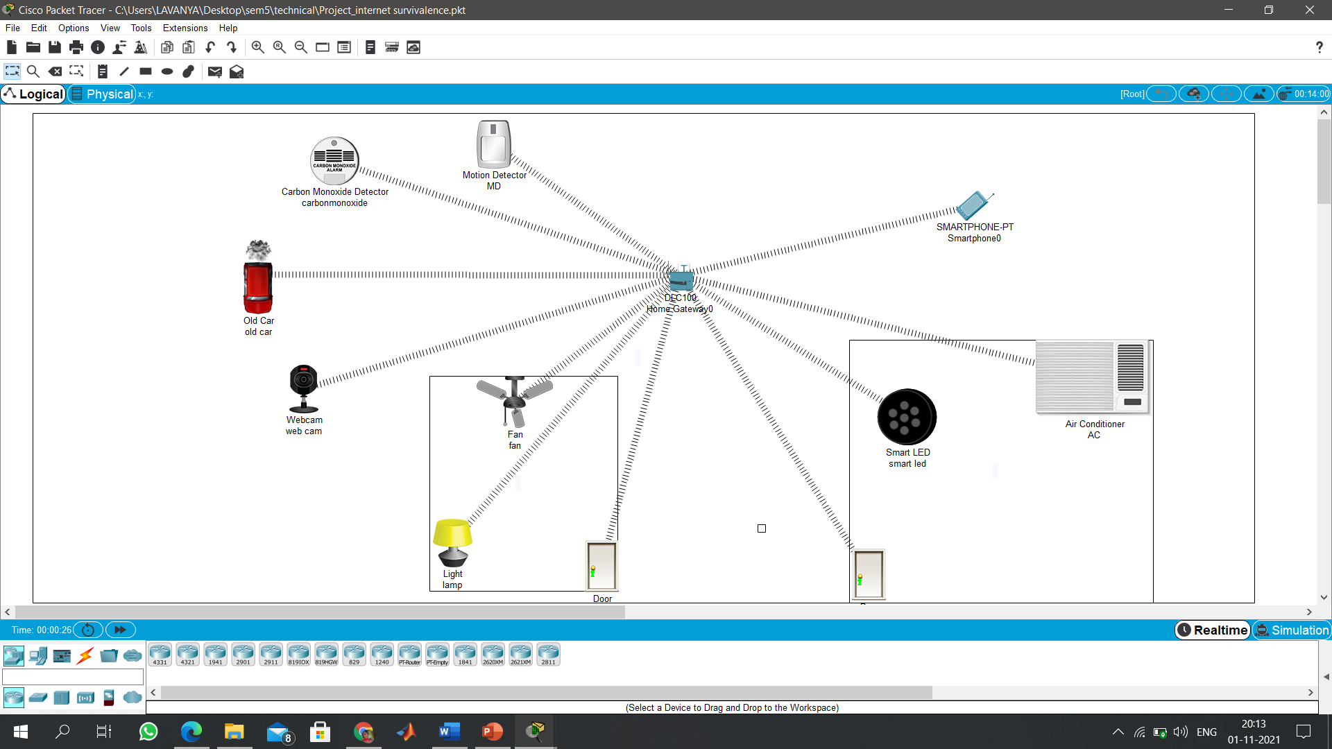

**Procedure:**

1.Take Cisco packet tracer software.

2. Drop DLC 100 Gateway on to the workspace

3. Drop Home appliances or smart Home appliances on to the workspace.

4.Set a Password on the Gateway and Connect all appliances to the Gateway

Wireless.

5.Set all Home appliances to the Home Gateway.

6.Web Browser on Smart phone login in to thatby using username and password.

Username: admin

Password: admin

7.Set the conditions On the appliances of the Smart home and observe the

changes.

**Outputs**

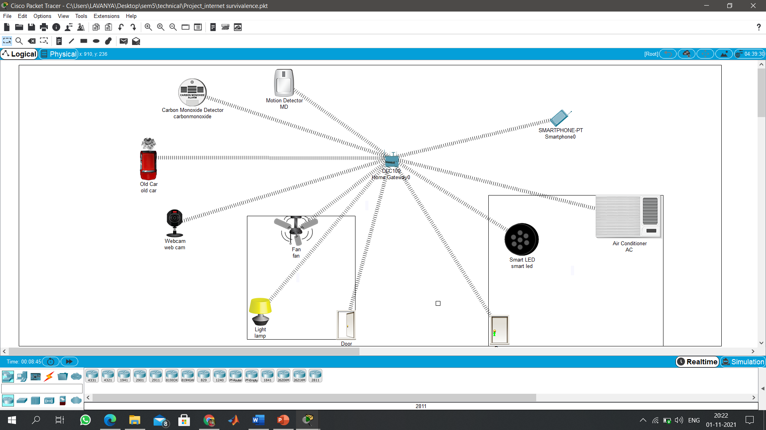

**When the door is opened the fan is automatically rotating in high speed.**

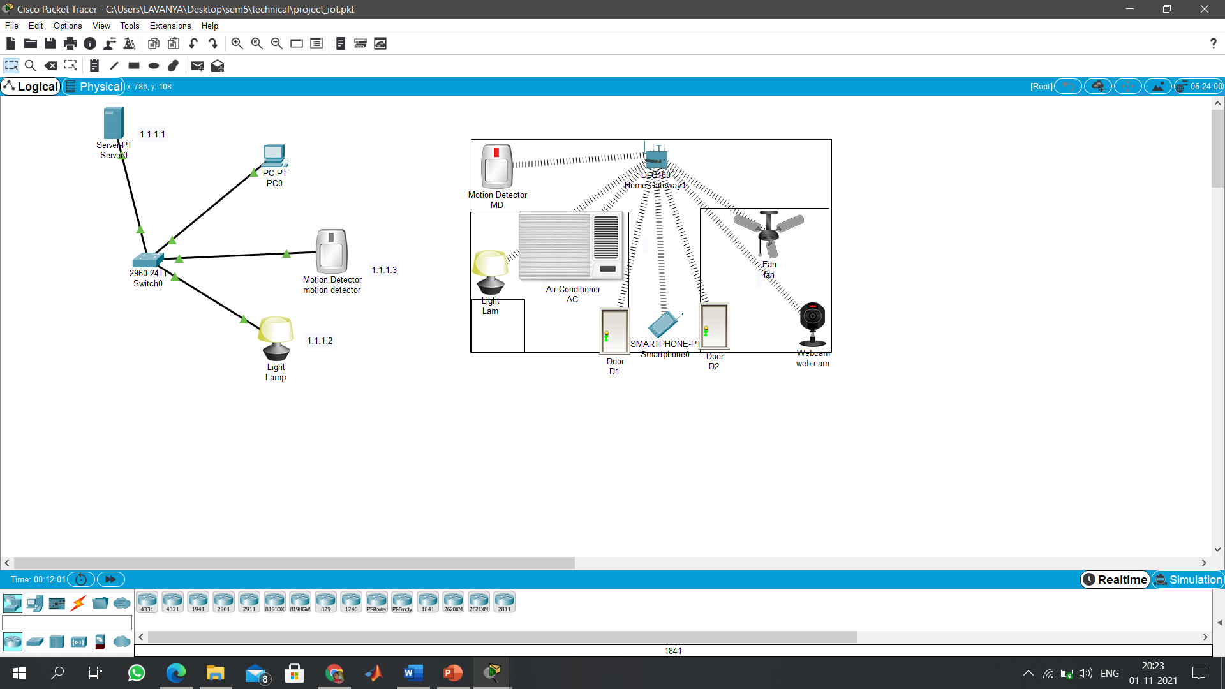

**When motion detector detects the motion the light is in on state.**

**CONCLUSION**

* internet of surveillance system which connects different security devices

and sensors.

* We used CISCO packet tracer simulation environment to analyse the

performance of proposed system in wireless and wireline environment**.**

**FUTURE SCOPE**

* As a future work, this method can be implemented using actual sensors and devices in physical environment using Cloud based IOT interface kits by evaluating more performance parameters.

**Reference:**

**https://1library.net/document/ynlx4elq-simulating-internet-of-surveillance-using-packet-tracer.html?utm_source=seo_title_list**